Science: Cookridge Holy Trinity Primary School Long Term Plan – Curriculum 2022 - 23
Key stage 1 Straight year groups
 |   AUTUMN |  | 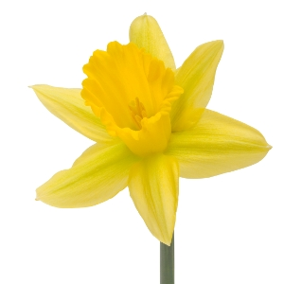  SPRING |  |   SUMMER
YEAR 1 | Animals, including humans  Seasonal Changes - Autumn |  | Everyday materials  Seasonal Changes – Winter  Seasonal Changes - Spring |  | Plants  Seasonal Changes - Summer
 | Seasonal changes
YEAR 2 | Uses of everyday materials | Living things and their habitats | Animals, including humans | Chicks  Seasons - Spring | Plants | Plants  Seasons – Summer

